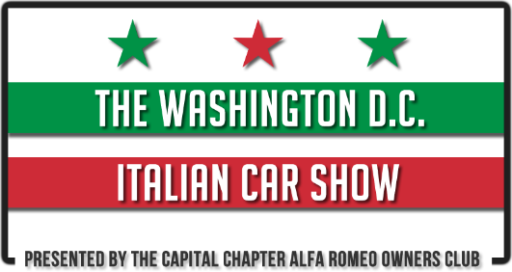
2019 Sponsor Registration Form
Sponsor Information
Company Name:
Address:
City: |  | State / Zip:
Contact Person: |  | Phone:
Email:
Sponsorship
[ ] Business Card - $25 |  |  | [ ] Inside Cover Advertisement - $125
[ ] ¼ Page Advertisement - $50 |  |  | [ ] Rear Cover Advertisement - $ 175
[ ] ½ Page Advertisement - $75 |  |  | [ ] Event Space - $75
[ ] Full Page Advertisement - $100 |  | [ ] New Car Dealer Space - TBA
SPONSOR REGISTRATION CUTOFF IS MAY 1ST, 2019
Make Checks Payable to  DC Italian Car Show | Submit Registration Form and Payment to:  DC Italian Car Show  London Auto Services LTD  C/O D.C. Italian Car Show  7718 Lee Highway  Falls Church, VA. 22042
With my signature, I and my heirs, release DC Italian Car Show and Nottoway Park from any liability for damages or injury to me, my guests, or my display property and materials while traveling to or from or while attending this event.
Signature |  | Date

