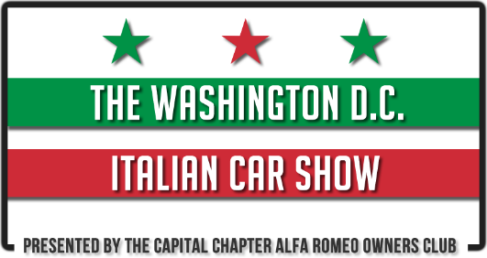
2020 Event Registration Form
Participant Information
First Name: |  | Last Name:
Address:
City: |  | State / Zip:
Cell Phone: |  | Email:
Club Affiliation:
Show Car Information
Year |  |  | Make
Model |  |  | Color
Unique Features
Registration Type
Pre-Registration (Until May 1st) (#Vehicles) at 15/Vehicle………….$_________
Same-day Registration (#Vehicles) at 20/Vehicle………….$_________

Make Checks Payable to  DC Italian Car Show | Submit Registration Form and Payment to:  London Auto Services LTD  C/O D.C. Italian Car Show  7718 Lee Highway  Falls Church, VA. 22042
With my signature, I and my heirs, release DC Italian Car Show and Nottoway Park from any liability for damages or injury to me, my guests, or my display property and materials while traveling to or from or while attending this event.
Signature |  | Date

